L'Hôpital's rule introduction
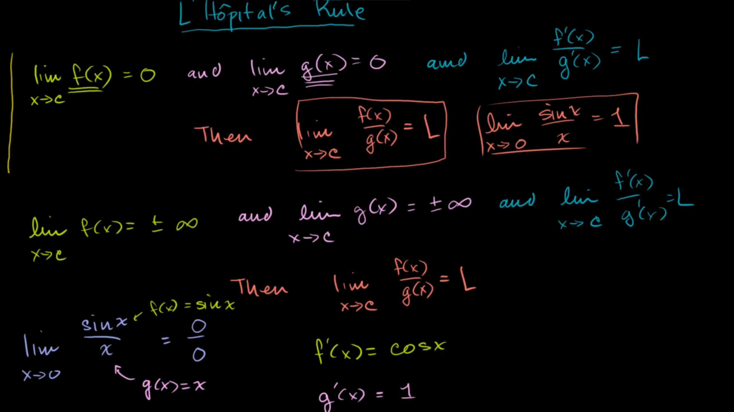
L'Hôpital's rule: limit at 0 example
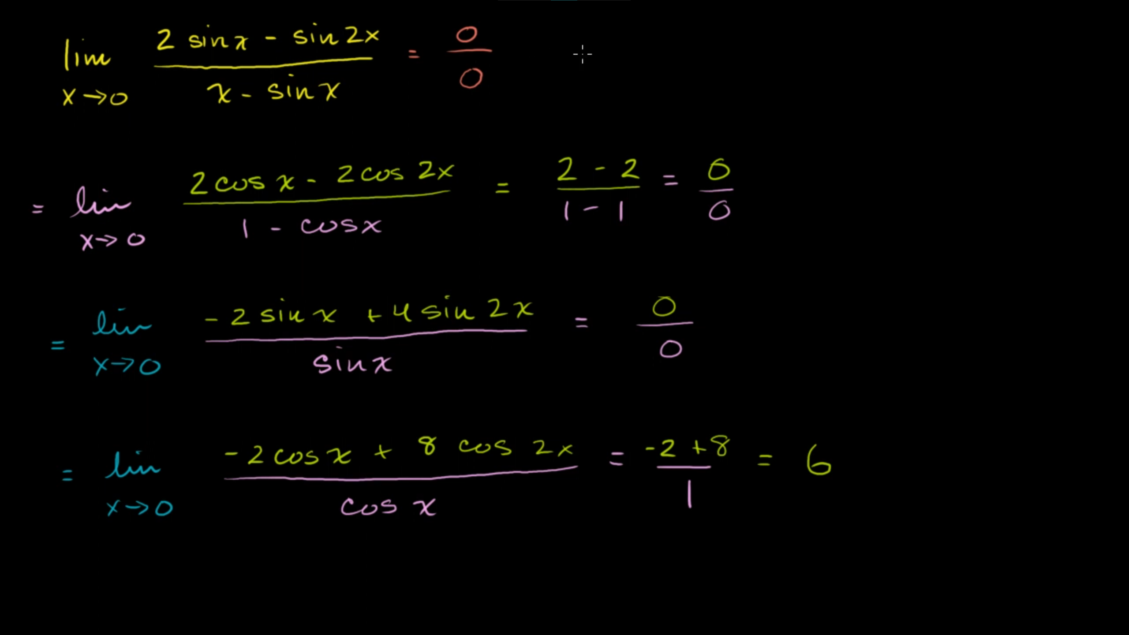
L'Hôpital's rule: limit at infinity example
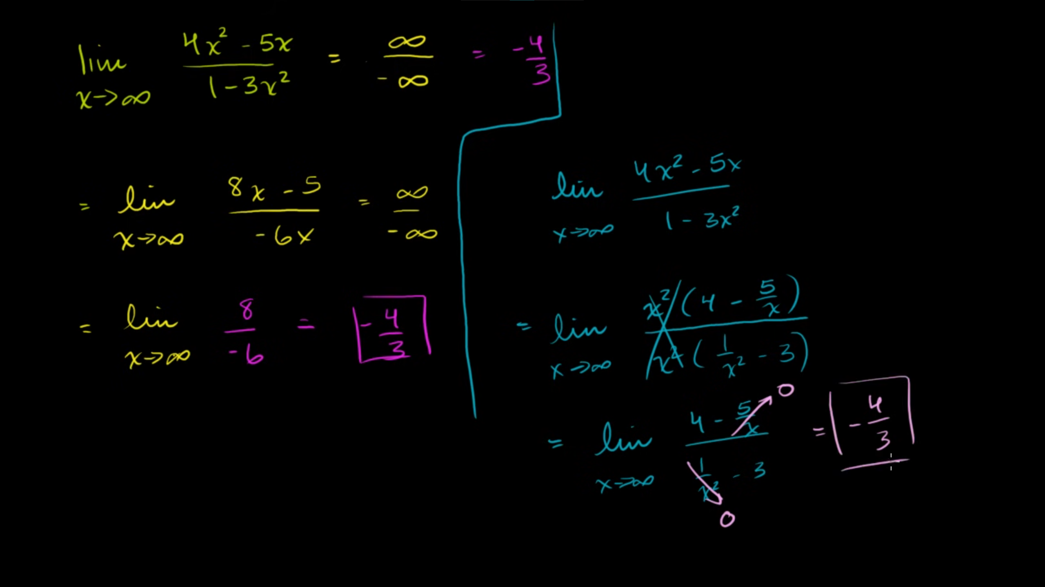
L'Hôpital's rule: challenging problem
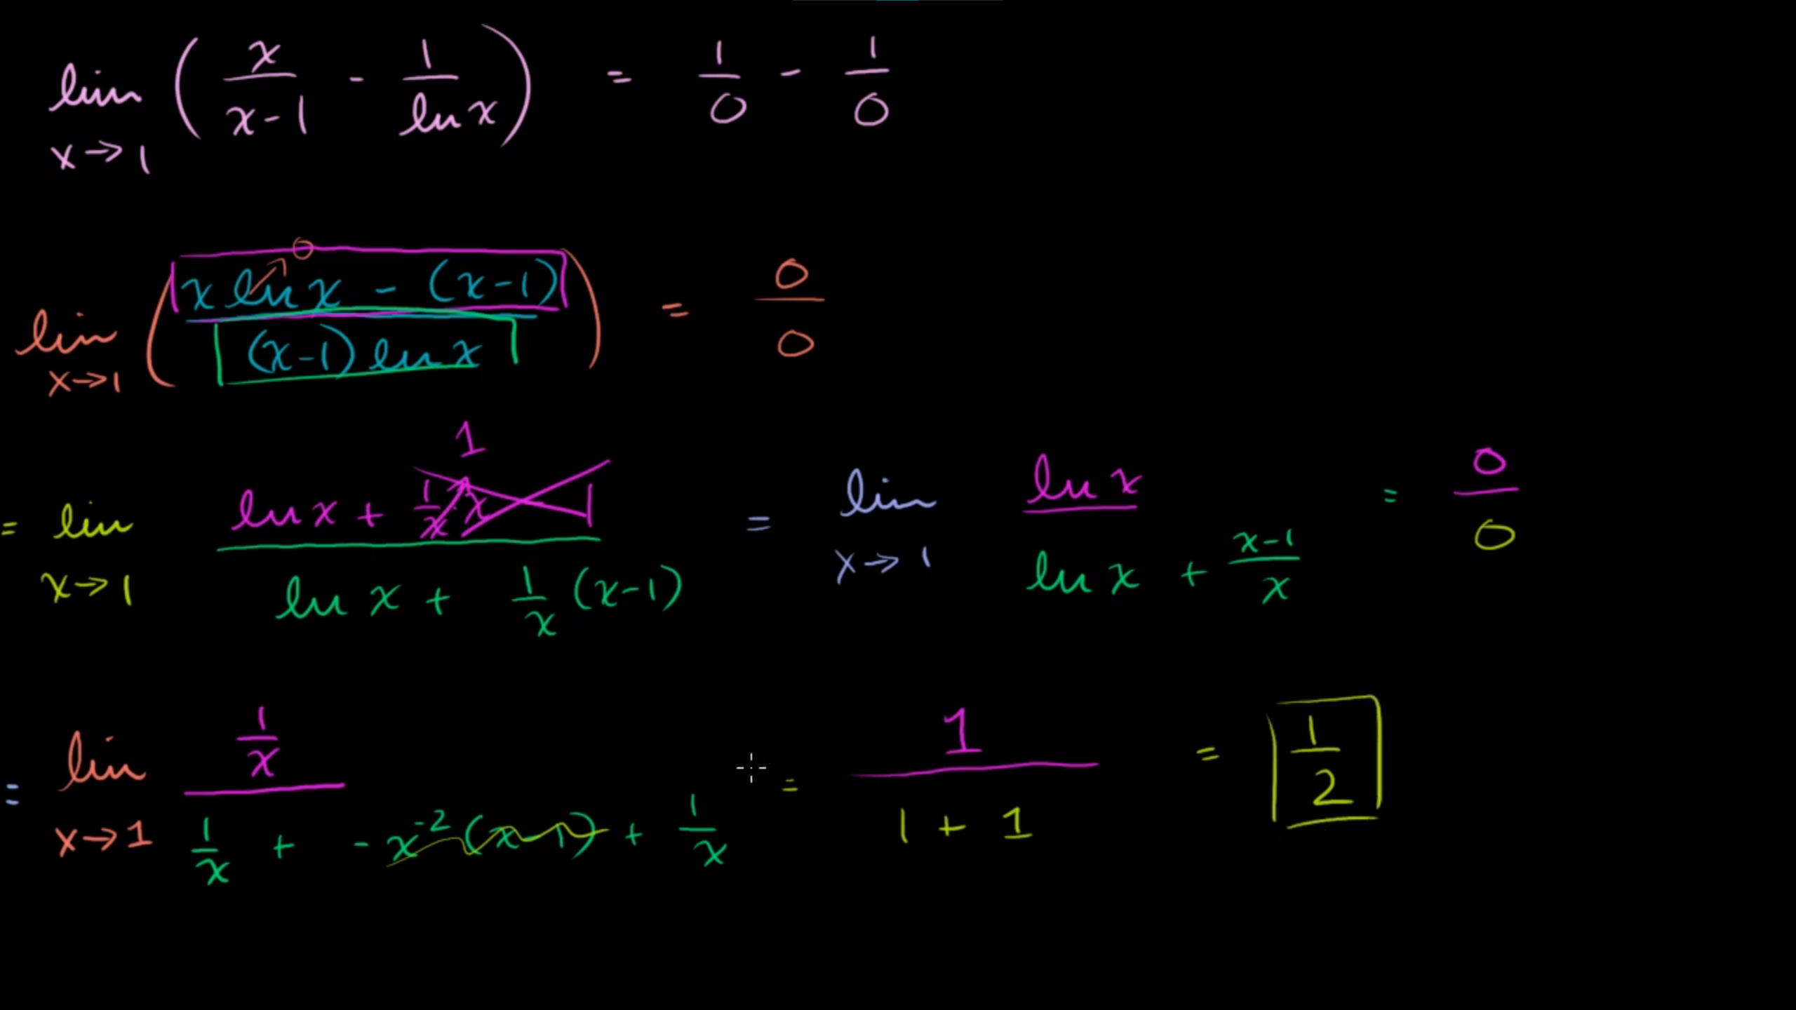
L'Hôpital's rule: solve for a variable
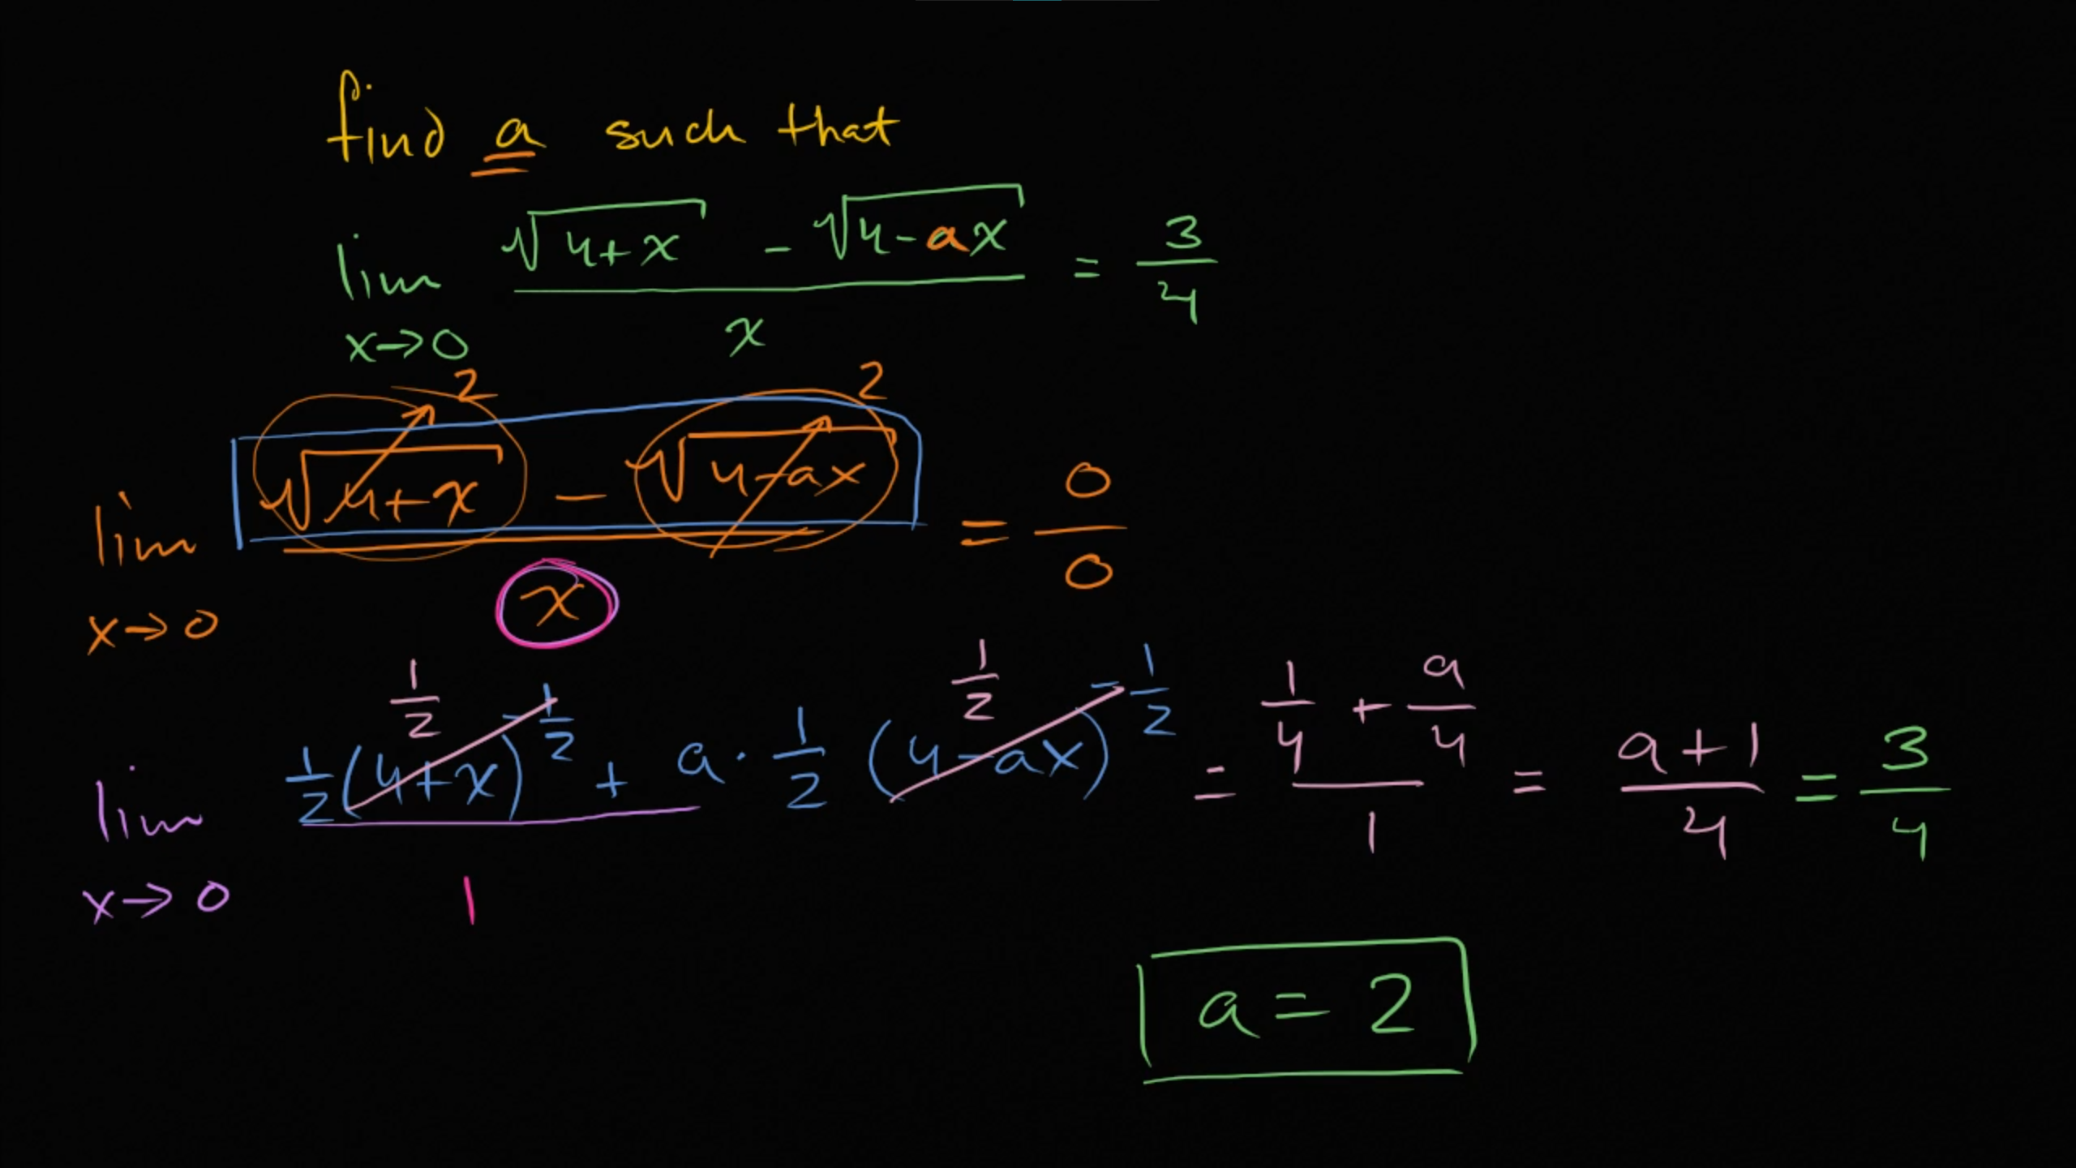
Proof of special case of l'Hôpital's rule
